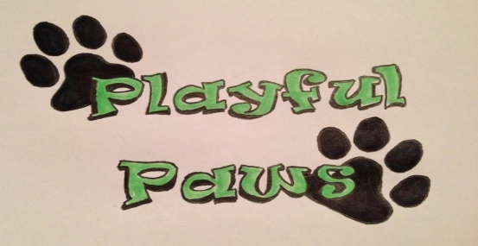

Doggy Daycare Application

Your Name___________________________________________________Date__________________

Dog’s Name___________________________________________

Address__________________________________City____________State______Zip________

Home Phone ________________Day Phone _______________Cell ____________________

E-Mail_______________________________________________________________

Emergency Contact Name and Phone Number_____________________________________________

Pet Information:

Sex: Male _____Female ____ Weight: __________ Breed: __________

Age of Dog _______ Spayed/Neutered ___Yes ____No

Veterinarian Name and Clinic_________________________ Phone Number__________________

Is your dog (please check all that apply)
____Allowed to run free in the home? Supervised or unsupervised (circle)
____Allowed to run free in fenced yard? Supervised or unsupervised (circle)
____Walked regularly?
____Exercised beyond walks? Examples: Chasing ball, Playing catch, etc(circle)
____Allowed to play with other dogs?

Is your dog allowed to have treats? ___Yes ____No. If yes, what kind?

Is your dog allergic to anything? ___Yes ____No. If yes, what kind?

Does your dog play with toys? ___Yes ____No. If yes, what kind?

Does your dog have any medical restrictions on his/her activities? ___Yes ____No. If yes, what kind?

How does your dog react to new people (including children)?
__________________________________________________________________________________________________________________________________________________________________________

How does your dog react to other dogs?
__________________________________________________________________________________________________________________________________________________________________________

Has your dog ever growled at someone or another dog? ___Yes ___ No.If yes, what circumstances?
__________________________________________________________________________________________________________________________________________________________________________

Has your dog ever bitten someone or another dog? ___ Yes ___ No. If yes, what circumstances

Is your dog housebroken? ___ Yes ___ No

What is your dog’s training history (please circle)
No training Trained your self Puppy Kindergarten
Group class, basic Group class, advanced Private training
Obedience titles/awards Agility Other

PERSONALITY
Please circle the words that describe your dog:
Mellow High energy High Strung Jealous
Calm Dominant Alert Fearful
Shy Unruly Happy Anxious
Submissive Timid Goofy Pushy
Playful Well-behaved Immature Mean
Silly Hyper Lively Protective
Sweet Aggressive Possessive Wonderful

BEHAVIORS
Please circle any behaviors that describe your dog and elaborate below:
Dog Aggressive People Aggressive Food Possessive
Jumps on People Mouthy/Bites Eats Poop
Eats Rocks Destroys Toys Noise Phobias
Destroys Furniture Toy Possessive Barks Excessively
Growls at Strangers Does not Obey Chews Excessively
Escapes Jumps Fences (how high?) Separation Anxiety
_______________________________________________________________________________________________________________________________________________________________________________________________________________________________________________________________

Is there anything else that you believe we should know about your dog (certain places he/she likes to be pet, special commands, areas of behavior you would like for us to reinforce, etc)?
__________________________________________________________________________________________________________________________________________________________________________

What is the main reason you have chosen daycare for your dog?
__________________________________________________________________________________________________________________________________________________________________________

Signature of Owner________________________________________________

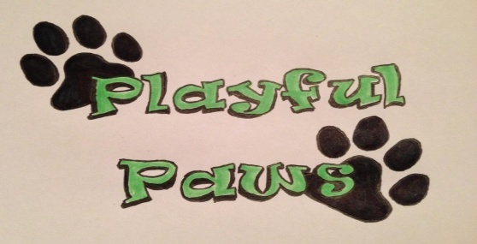

Doggy Daycare Pet Care Agreement

Name of Dog________________________________________________

- I understand that Playful Paws LLC, has relied upon my representation that my dog is in good health and has not injured or shown aggression and/or threatening behavior to any person or dog in admitting my dog for services at their facility.
- I further understand that I am solely responsible, financially or otherwise, for any harm or damage caused by my dog while attending any services provided by Playful Paws LLC.
- I further understand that Playful Paws LLC , their owners, staff, partners and volunteers will not be liable, financially or otherwise, for injuries to my dog, myself, or any property of mine while my dog is participating in services provided by Playful Paws LLC. I hereby release Playful Paws LLC of any liability of any kind arising from my dog’s involvement in any and all services provided by Playful Paws LLC.
- I further understand that in the event of a medical emergency, that Playful Paws LLC, at its sole discretion, deems to need the immediate attention of a licensed veterinarian, I authorize Playful Paws LLC to seek medical attention at the closest available veterinary facility. I further agree that I am financially responsible for any medical treatment my pet(s) receives as a result of a medical emergency while attending services provided by Playful Paws LLC.
- I further understand by allowing my dog to participate in services offered by Playful Paws LLC, I hereby agree to allow Playful Paws LLC to take photographs or use images of my pet for publication and/or promotion.
- I further understand that Playful Paws LLC requires that my dog be up to date on all vaccinations and the following information will be supplied to Playful Paws LLC
- Written Proof of Bordetalla vaccination
- Written Proof of DHLPP vaccination
- Written Proof of fecal exam
- Current PA dog license number and copy of form
- Written Proof of Rabies vaccination

Signature of Owner________________________________________________

